Shreeyjan Shrestha
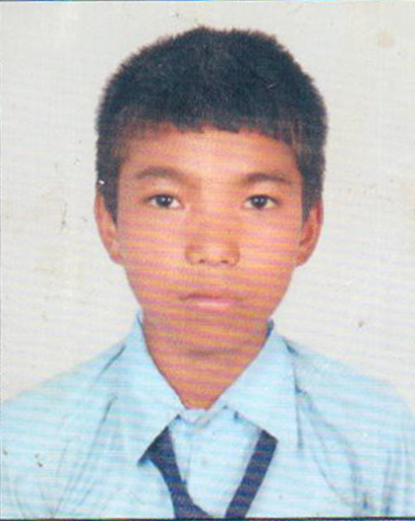
Shreeyjan Shrestha, is a regular student studying at grade 9 in Shree Kalinaag Higher Secondary School. He lives in Lamidadha, Dolaka. He had lost his mother when he was small. After the death of his mother, his father started drinking alcohol. One day his father went missing. People searched his father & even they reported to the police station but no one can find him.
Though he don't loose his hope and he goes every Sunday with father's photo in the police station. Still Shreeyjan loves and misses his parents. Now he is an orphan and his mind is frausted but loved by all the villagers.
He don't have any elder's to guide nor to spend money for his studies so he is supported by school management as he lives there and he works at the canteen of school as part-time job. His aim is to be a policeman and find out his father as well as criminal and bring peace in the country.

